Event Database Management System

By
Supriya Yadav-AF05213247
Harshita Shukla-AF05213668

Index
Sr.no | Topic | Page no
1 | Title of Project | 1
2 | Acknowledgement | 3
3 | Abstract | 4
4 | Introduction | 5
5 | Objective | 6
6 | System Analysis | 7
7 | System Design | 22
8 | Screenshots | 30
9 | Coding | 34
10 | Testing | 35
11 | Report | 36
12 | Future Scope | 37
13 | Conclusion | 38
14 | References | 39

Acknowledgement
The project “Event Database Management System” is the Project work carried out by
Name | Enrollment No
Supriya Yadav | AF05213247
Harshita Shukla | AF05213668

Under the Guidance.
We are thankful to my project guide for guiding me to complete the Project. His suggestions and valuable information regarding the formation of the Project Report have provided me a lot of help in completing the Project and its related topics.
We are also thankful to my family member and friends who were always there to provide support and moral boost up.

Abstract
The Event-Based Management System is a Django-based web application developed to manage event-related information in a centralized system. The project provides functionality for managing events and related details such as event name, description, host information, date and time, location, fee, and event images. The system uses MySQL as the database for storing and managing the application data. It provides an organized way to maintain event information and makes event management easier through a web-based interface.
The system also includes separate management of event-related data through the Django application, allowing authorized users to add, view, update, and manage the required information. The use of Django, Python, HTML, CSS, and MySQL provides the basic framework for developing and maintaining the system. Overall, the project is designed to provide a structured platform for storing and managing event information efficiently.

- Introduction

In today’s age of Information Communication and Technology, technology has become an important part of our daily lives. The development of web applications has made it easier to store, access, and manage information through online platforms. Web-based systems provide a convenient and organized way to manage different types of information from a centralized platform. Event management is one such area where maintaining accurate and organized information is important for managing events effectively.
Our project aims to develop an Event-Based Management System website that provides a structured platform for managing event-related information. The system allows details such as event name, description, host details, event date and time, location, event fee, and event image to be stored and managed. The application is developed using Django and Python, with MySQL used for database management. The system helps in maintaining event records in an organized manner and provides an efficient web-based solution for managing event information.

1.1 Objective of the Present Work
The objectives of this project are as follows:
- To develop a web-based Event-Based Management System using Django and Python.
- To provide a centralized platform for storing and managing event-related information.
- To maintain important event details such as event name, description, host details, date and time, location, event fee, and event image.
- To provide an organized way to add and manage event records through the web application.
- To use MySQL for storing and managing event-related data efficiently.
- To provide a simple and structured interface for managing event information.
- To make event information easily accessible through the web-based system.

System Analysis

3.1 Problem Definition
Managing event information manually can make it difficult to maintain event records in an organized and centralized manner. Details such as event name, description, host details, date and time, location, event fee, and event image need to be stored properly so that they can be easily managed and accessed.
This project solves these problems by providing a web-based Event-Based Management System developed using Django and Python. The system allows event-related information to be stored and managed through a centralized application, while MySQL is used to maintain the database records. The system makes event management more organized and reduces the difficulty of handling event information manually.

3.2 Preliminary Investigation

Purpose
The Event-Based Management System is designed to provide a web-based platform for managing event information in an organized manner. It aims to provide a centralized system where event details can be stored, maintained, and managed through the application.

Benefits
The system provides several advantages:
- Centralized Event Management: Event-related information can be maintained in one system.
- Organized Information: Details such as event name, description, host details, date and time, location, fee, and image can be stored systematically.
- Easy Data Management: Event records can be managed through the web application.
- Database Management: MySQL provides storage for maintaining the event-related records.
- Web-Based Access: The system provides an interface for managing event information through a web browser.

Proposed System
The proposed system provides a structured approach to event management:
- Event details can be stored and managed through the Django-based application.
- The system maintains information such as event name, description, host details, date and time, location, event fee, and event image.
- MySQL is used to store and manage the event-related data.
- The system provides a centralized and organized platform for maintaining event records.

3.3 Feasibility Study
The feasibility study evaluates whether the Event-Based Management System is practical and achievable using the available technologies and resources. It helps determine whether the proposed system can be developed and used effectively within the project requirements.

Types of Feasibility Analysis
Technical Feasibility
- The system is developed using Python and Django for the application development.
- HTML and CSS are used for developing the web interface.
- MySQL is used for storing and managing the system data.
- The technologies used are suitable for developing a web-based event management system.
Economic Feasibility
- The project uses commonly available technologies such as Python, Django, and MySQL.
- The system can be developed using existing computer hardware and software resources.
- The use of these technologies helps keep the development cost low.
Operational Feasibility
- The system provides a web-based interface for managing event information.
- Event details can be maintained in an organized manner.
- The centralized database makes event information easier to manage.
Schedule Feasibility
- The project can be developed through different stages such as requirement analysis, design, coding, testing, and implementation.
- The development process can be completed within the planned project schedule.

3.4 Project Planning

Purpose of Project Planning
Project planning provides a structured approach for developing the Event-Based Management System. It helps organize the different activities involved in the development of the project and ensures that the required work is completed systematically.

Phases Covered in the Plan
The planning is divided into different phases:
- Preliminary Investigation – Understanding the project requirements, purpose, and scope.
- System Analysis – Identifying the problems and determining the requirements of the system.
- System Design – Designing the application structure, database, and user interface.
- Coding – Developing the Event-Based Management System using Python and Django.
- Database Implementation – Creating and managing the required data using MySQL.
- Testing – Checking the system functionality and identifying errors.
- Implementation – Running and using the completed system for managing event-related information.

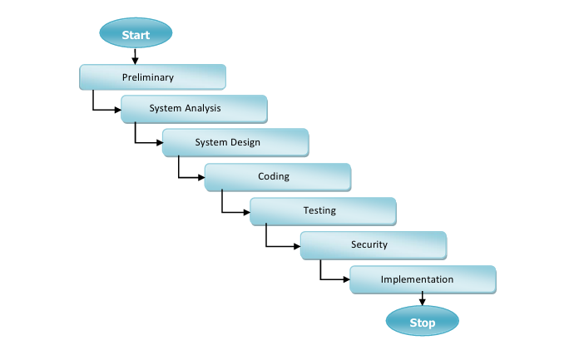

3.5 Software Requirement Specification (SRS)
The Software Requirement Specification (SRS) defines the basic requirements of the Event-Based Management System to ensure proper functionality, usability, and maintainability of the application.

System Overview
The Event-Based Management System is a Django-based web application developed to manage event-related information. The system stores and manages details such as event name, description, category, start date, end date, venue, maximum number of participants, registration fee, organizer, and event image. The system uses MySQL for storing and managing the application data.
The system mainly consists of the following functionality:
- Event Management Module – Used to store and manage event information.
- Event Organizer Management – Maintains the organizer information associated with events.
- Database Management – Stores event-related information in the MySQL database.
- Admin Management – Django Admin provides a centralized interface for managing the application data.

Software & Hardware Requirements

Software Requirements
- Programming Language: Python
- Framework: Django 4.2.6
- Database: MySQL 8.0
- Database Connector: mysqlclient
- Image Processing: Pillow
- Frontend: HTML and CSS
- Development Environment: Visual Studio Code
- Operating System: Windows

Hardware Requirements
- Processor: Intel i3 or higher
- RAM: Minimum 4 GB
- Storage: Minimum 10 GB of available space
- Display: Standard monitor
- Connectivity: Internet connection when required for development and database access

3.6 Functional Requirements

1. Event Management Module
The system provides functionality to manage event information:
- Add new event records.
- Store the event name and description.
- Select an event category such as Conference, Concert, Workshop, Sports, Wedding, or Other.
- Store the event start date and end date.
- Store the event venue.
- Specify the maximum number of participants.
- Store the registration fee.
- Associate an event with its organizer.
- Upload an event image.
- View and manage stored event information.

2. Organizer Management
The system maintains organizer information using the Django user system. An event can be associated with an organizer, allowing the system to identify the user responsible for the event.

3. Database Management
The system uses MySQL to store event-related information. The database maintains the records required by the application and allows the Django application to perform database operations.

4. Admin Management
The Django Admin interface provides authorized administration of the system data. The administrator can manage the records stored in the application through the administrative interface.

3.7 Software Engineering Paradigm
The development of the Event-Based Management System follows a structured software development approach. The Waterfall Model is used to organize the development process into a sequence of clearly defined phases. Each phase focuses on a specific part of the project development process.

Development Model: Waterfall Model
The Waterfall Model follows a systematic sequence in which the project progresses through different stages from initial investigation to final implementation.

Phases of the Waterfall Model
- Preliminary Investigation – Understanding the purpose, requirements, and scope of the Event-Based Management System.
- System Analysis – Identifying the problems and determining the functional requirements of the system.
- System Design – Designing the application structure, database, and user interface.
- Coding – Developing the application using Python and Django and connecting it with MySQL.
- Testing – Testing the application to identify errors and verify that the required functions work correctly.
- Security – Using Django's built-in authentication and access-control features to manage authorized access to the system.
- Implementation – Running and using the completed Event-Based Management System for managing event-related information.

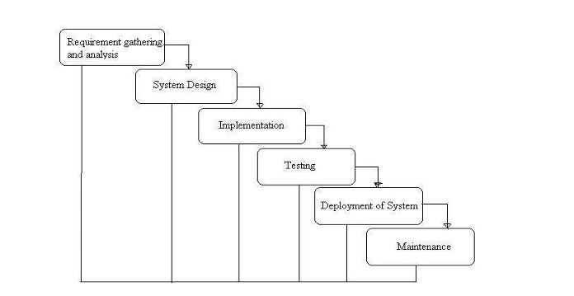

Phases of Development
- Requirement Analysis & System Study
  - Identifying the purpose, objectives, and requirements of the Event-Based Management System.
  - Understanding the information required for managing events and related records.
  - Defining the main functionalities and system requirements.
- System Design
  - Designing the structure of the Django application and database.
  - Planning the database tables and relationships required for storing event-related information.
  - Designing the user interface for managing event information.
- Implementation (Coding)
  - Backend development using Python and Django.
  - Frontend development using HTML and CSS.
  - Database integration with MySQL.
  - Implementing event-related functionality and image handling using the required Django components.
- Testing & Debugging
  - Testing the different functionalities of the Event-Based Management System.
  - Checking database operations and event information management.
  - Identifying and correcting errors during development.
- Implementation & Maintenance
  - Running the completed system and verifying its proper operation.
  - Maintaining event records and making required changes to the system when necessary.

3.8 Data Flow Diagram
A Data Flow Diagram (DFD) is a graphical representation of the flow of data within the Event-Based Management System. It shows how data enters the system, how it is processed, and where the information is stored. The DFD helps in understanding the movement of event-related data between users, system processes, and the database.
The objective of a DFD is to provide a clear representation of the scope and data flow of the system. It helps in understanding how event information is submitted, processed, stored, and managed within the Event-Based Management System. The DFD can also be used as a communication tool during system analysis and design.
The following observations about DFDs are essential:
- Unique Names: All entities, processes, and data stores should have clear and unique names so that they can be easily identified.
- Data Flow Representation: A DFD represents the movement of data between different components of the system. The arrows show the flow of data and not the sequence of events.
- Process Representation: Each process represents an operation that receives input data and produces output data.
- Data Storage: Data stores represent locations where information is stored and can be accessed by other processes when required.
- Avoid Unnecessary Details: A DFD should focus on the main flow of data and should not include unnecessary implementation details.

Standard Symbols for DFD
Circle: A circle or bubble represents a process that transforms input data into output data.
Data Flow: An arrow represents the movement of data from one process, entity, or data store to another.
Data Store: A set of parallel lines represents a data store where system information is stored for later use.
Source or Sink: A source or sink represents an external entity that provides data to the system or receives data from the system.
For the Event-Based Management System, the main data flow involves the user or administrator providing event-related information to the system, the Django application processing the information, and the MySQL database storing the required event records.

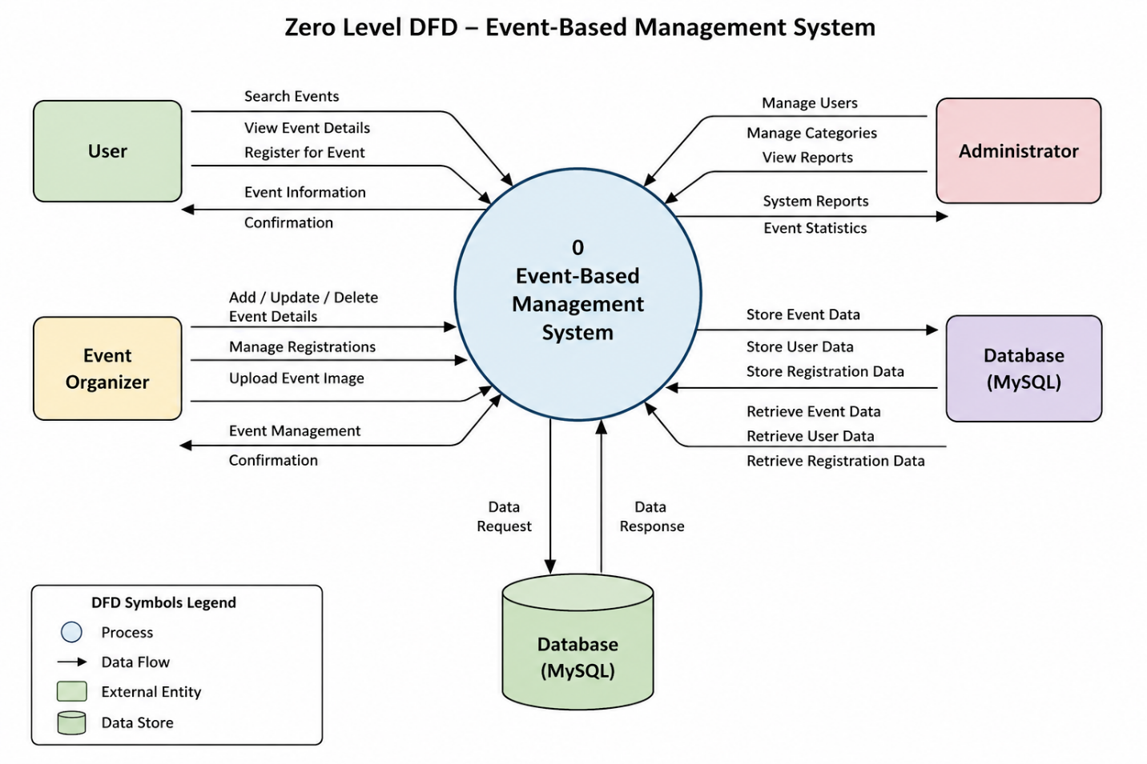
The Zero Level DFD of the Event-Based Management System shows the main interactions between the user, the central Event-Based Management System, and the database. It represents the flow of event-related information such as event details, organizer information, event date and time, location, event fee, participant details, and event images. The diagram highlights how data is provided to the system, processed through the application, and stored or retrieved from the MySQL database for event management.

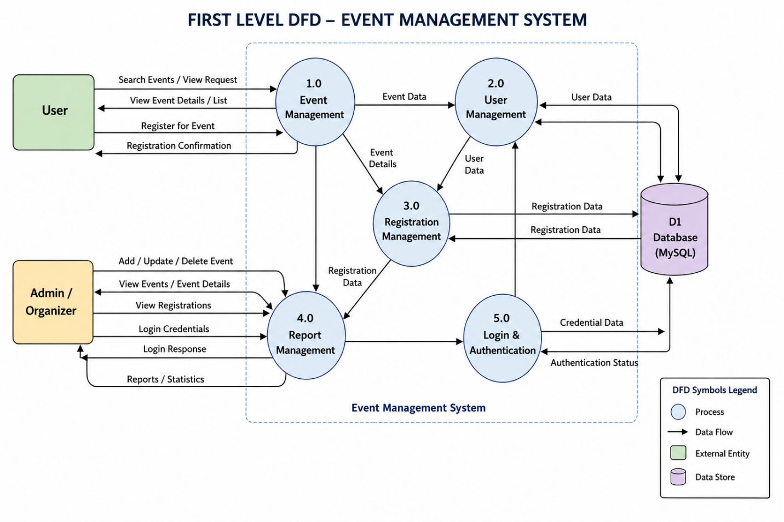
The First Level DFD of the Event-Based Management System represents the major processes involved in managing events and related information. The system is divided into different processes such as Event Management, User Management, Event & Organizer Management, Registration Management, and Login & Authentication. Users can search and view events and register for available events, while administrators or organizers can add, update, and delete event information. The system stores and retrieves user, event, organizer, registration, and authentication data through the MySQL database. The diagram shows the flow of data between the users, administrator or organizer, system processes, and database.

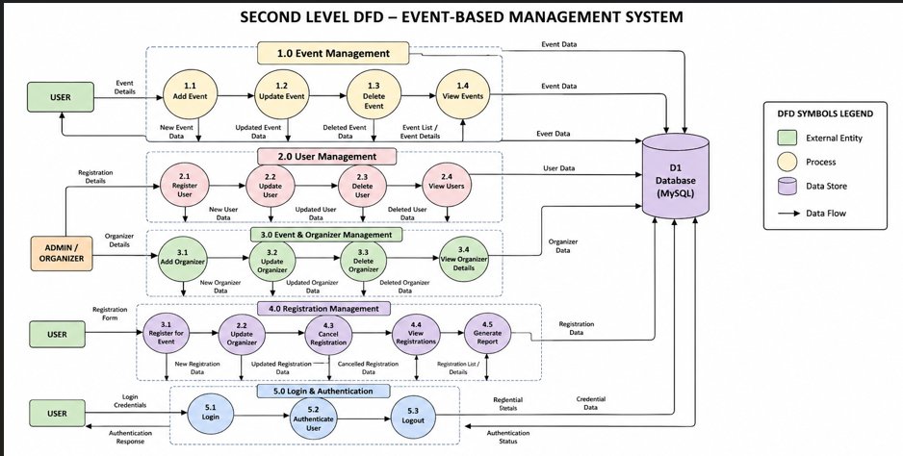

The Second Level DFD of the Event-Based Management System provides a detailed representation of the major processes involved in the system. The Event Management process is divided into adding, updating, deleting, and viewing event information. The User Management process handles user-related information, while Event and Organizer Management manages organizer details associated with events. The Registration Management process handles event registration information. The Login and Authentication process manages user login and authentication. All the required information is stored in and retrieved from the MySQL database, showing the detailed flow of data between the users, administrator or organizer, system processes, and database.

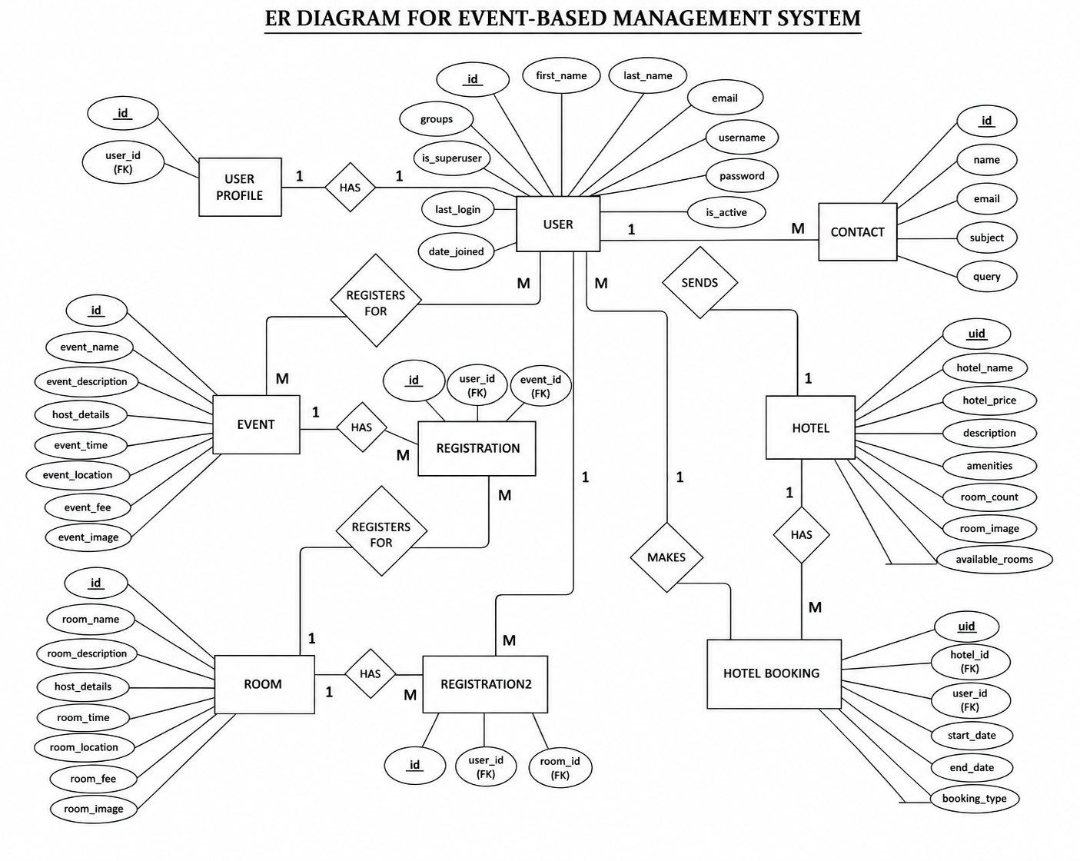

4. System design

4.1 Modules
The Event-Based Management System consists of different modules that work together to manage event, user, registration, hotel, booking, and contact information.

1. User Module
Users can:
- Create and use an account through the Django authentication system.
- View available event information.
- View details such as event name, description, host details, event time, location, fee, and event image.
- Register for events through the registration system.
- Make hotel bookings by providing the required booking details.
- View and manage their profile information.
- Submit queries through the Contact module.

2. Event Module
The Event module manages the information related to events. It stores:
- Event name
- Event description
- Host details
- Event date and time
- Event location
- Event fee
- Event image
The event information is stored in the database and can be managed through the system.

3. Registration Module
The Registration module manages user registrations for events. It connects users with events and stores the registration information. The system uses a unique constraint on the combination of user and event so that the same user cannot register for the same event more than once.

4. Hotel Module
The Hotel module manages hotel-related information. It stores details such as:
- Hotel name
- Hotel price
- Description
- Amenities
- Room count
- Room image
- Available rooms
The module also maintains the creation and update information for hotel records.

5. Hotel Booking Module
The Hotel Booking module manages hotel bookings made by users. It stores:
- Hotel information
- User information
- Start date
- End date
- Booking type
The booking type can be Pre Paid or Post Paid. The system also validates the booking dates to ensure that the end date is after the start date. When a booking is successfully saved, the available room count of the selected hotel is reduced by one.

6. User Profile Module
The User Profile module is connected to the Django User model through a one-to-one relationship. It is used to maintain a profile associated with each user account.

7. Contact Module
The Contact module allows users to submit queries to the system. It stores:
- Name
- Email
- Subject
- Query
The submitted contact information is stored in the database for management.

4.2 DATA STRUCTURE OF ALL MODULES
The Event-Based Management System uses a relational database structure to store and manage information related to users, events, registrations, hotels, bookings, profiles, and contact queries. The database contains application-specific tables created from the Django models along with tables created by Django's built-in authentication and administration system.
The active project contains 6 customized application models:
- Event
- Registration
- Hotel
- HotelBooking
- UserProfile
- Contact
The project also uses Django's built-in User model and its related authentication tables.

Customized Tables Details

1. Event Table: events_event
This table stores the details of events created and managed in the Event-Based Management System.
Fields:
- id – Primary key
- event_name – Name of the event
- event_description – Description of the event
- host_details – Details about the event host
- event_time – Date and time of the event
- event_location – Location of the event
- event_fee – Fee associated with the event
- event_image – Image associated with the event

2. Registration Table: events_registration
This table stores the registration details of users for events.
Fields:
- id – Primary key
- user_id – Foreign key referring to the Django User
- event_id – Foreign key referring to the Event
The table uses a unique constraint on user_id and event_id to prevent duplicate registration of the same user for the same event.

3. Hotel Table: rooms_hotel
This table stores information about hotels available in the system.
Fields:
- uid – Primary key using UUID
- created_at – Date on which the record was created
- updated_at – Date associated with the record update
- hotel_name – Name of the hotel
- hotel_price – Price of the hotel
- description – Description of the hotel
- amenities – Available hotel amenities
- room_count – Total room count
- room_image – Hotel room image
- available_rooms – Number of currently available rooms

4. Hotel Booking Table: rooms_hotelbooking
This table stores hotel booking information made by users.
Fields:
- uid – Primary key using UUID
- created_at – Date on which the booking record was created
- updated_at – Date associated with the booking record update
- hotel_id – Foreign key referring to the Hotel
- user_id – Foreign key referring to the Django User
- start_date – Booking start date
- end_date – Booking end date
- booking_type – Type of booking
The booking_type field provides two choices: Pre Paid and Post Paid.

5. User Profile Table: user_userprofile
This table stores the profile information associated with a Django user account.
Fields:
- id – Primary key
- user_id – One-to-one foreign key referring to the Django User
Each user can have one associated UserProfile.

6. Contact Table: contact_contact
This table stores queries submitted through the Contact module.
Fields:
- id – Primary key
- name – Name of the person submitting the query
- email – Email address
- subject – Subject of the query
- query – Query or message submitted by the user

Default Tables Details
The project also uses tables provided by Django's built-in authentication, permission, administration, content type, migration, and session systems.

1. auth_user
This table stores the user account information used by Django's authentication system, including username, password, email, name, and account status information.

2. auth_group
This table stores groups used by Django to organize users and assign permissions.

3. auth_permission
This table stores the permissions available for the different models in the Django application.

4. auth_group_permissions
This table manages the relationship between groups and their assigned permissions.

5. auth_user_groups
This table manages the relationship between users and groups.

6. auth_user_user_permissions
This table manages the relationship between individual users and their assigned permissions.

7. django_admin_log
This table stores records of actions performed through the Django Admin interface.

8. django_content_type
This table stores information about the models registered in the Django project.

9. django_migrations
This table keeps track of the migrations that have been applied to the database.

10. django_session
This table stores session-related information used by Django for maintaining user sessions.

SCREENSHOTS
HOME PAGE:
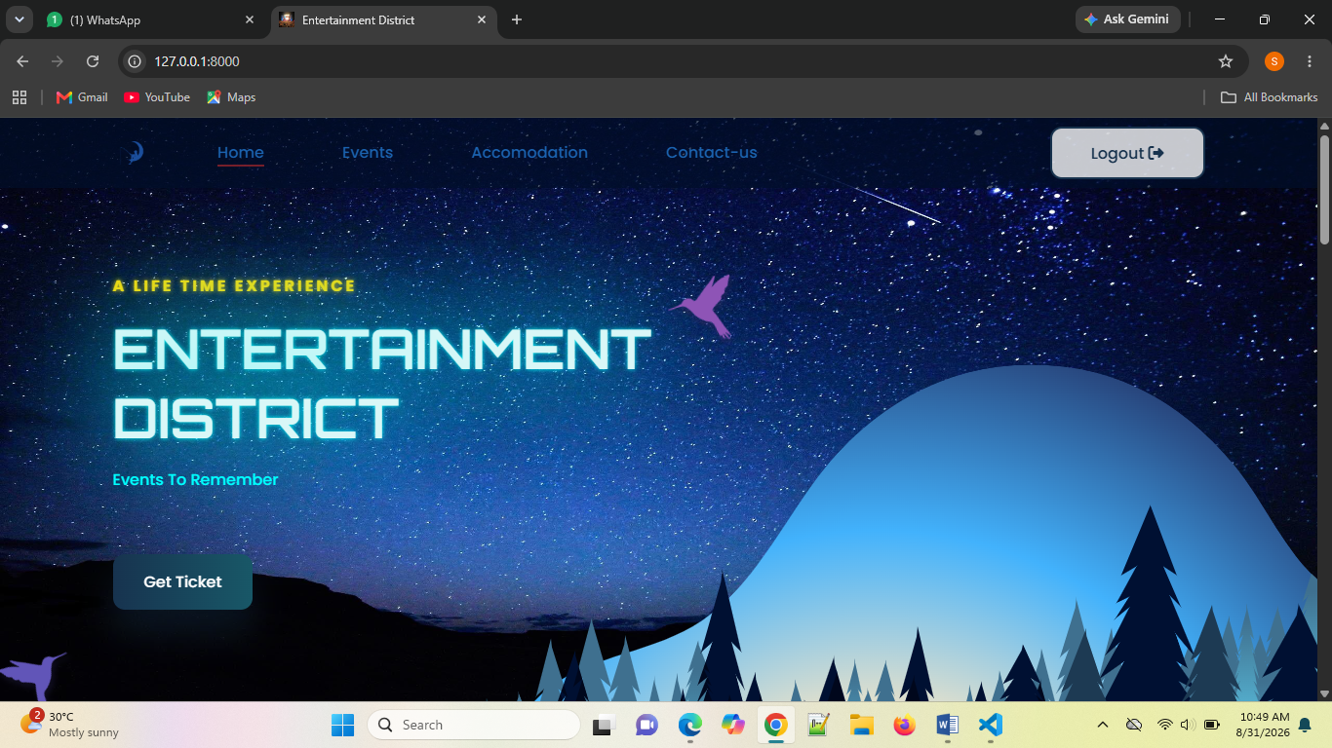

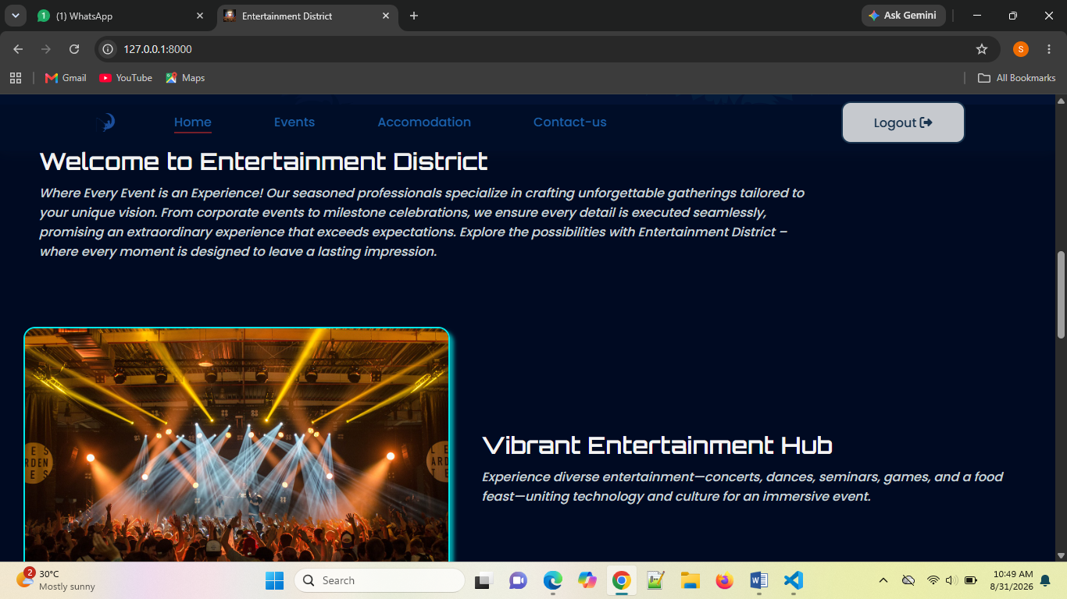
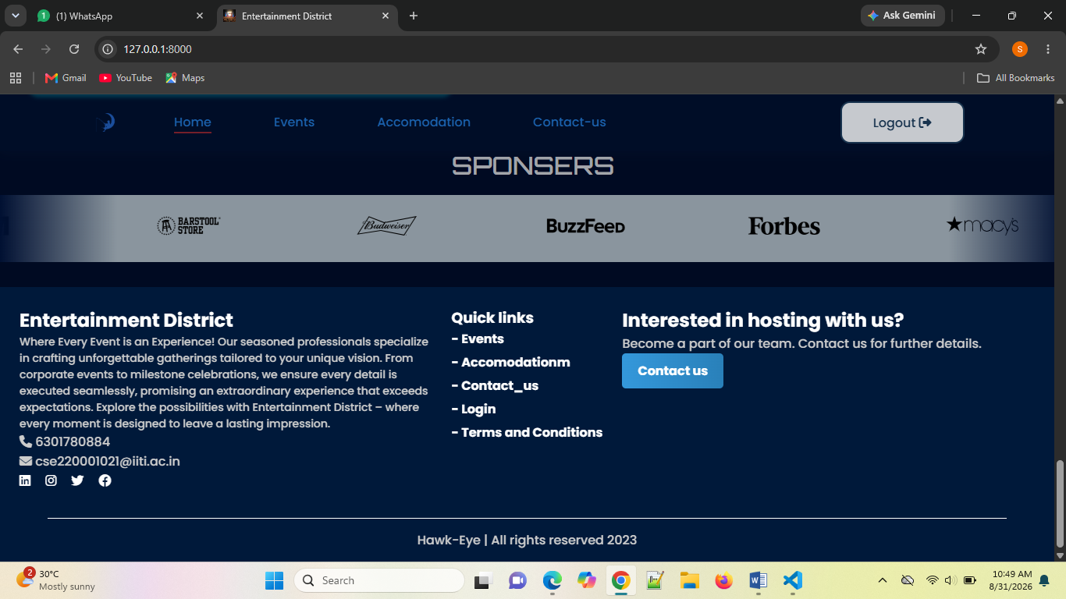

EVENTS:
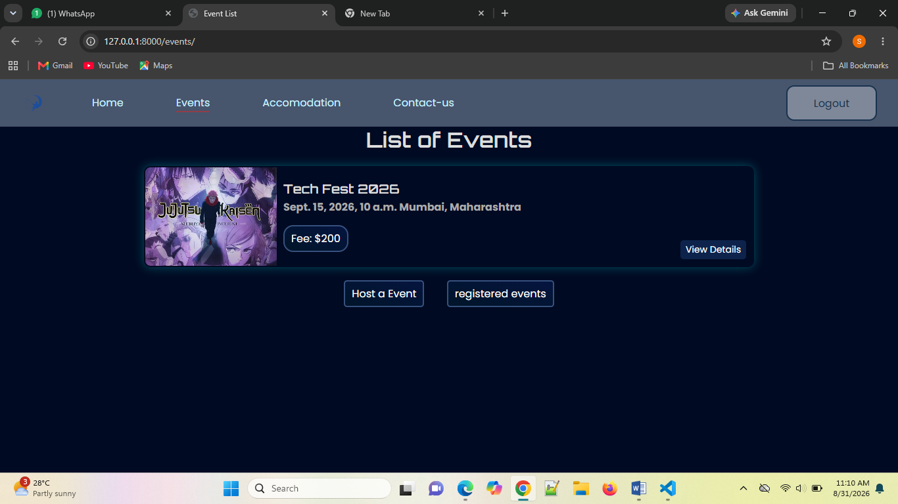

ACCOMENDATION:
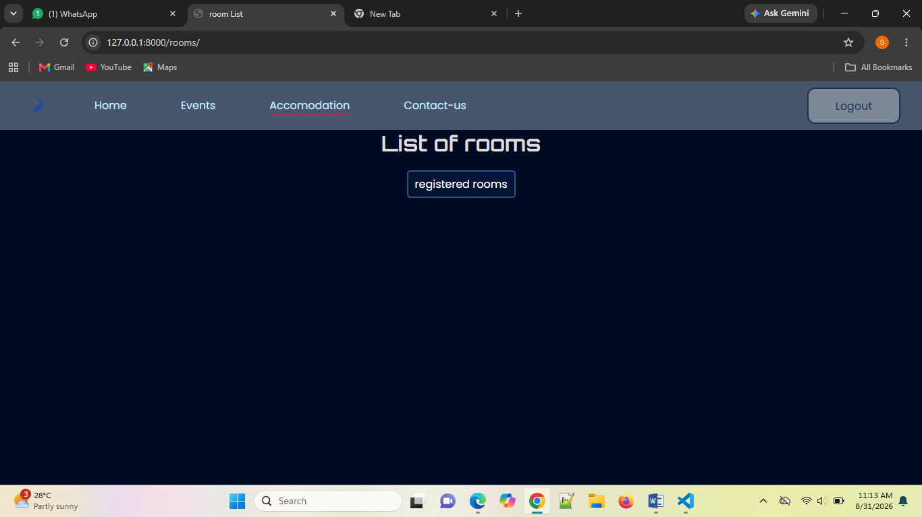

Contact-us:
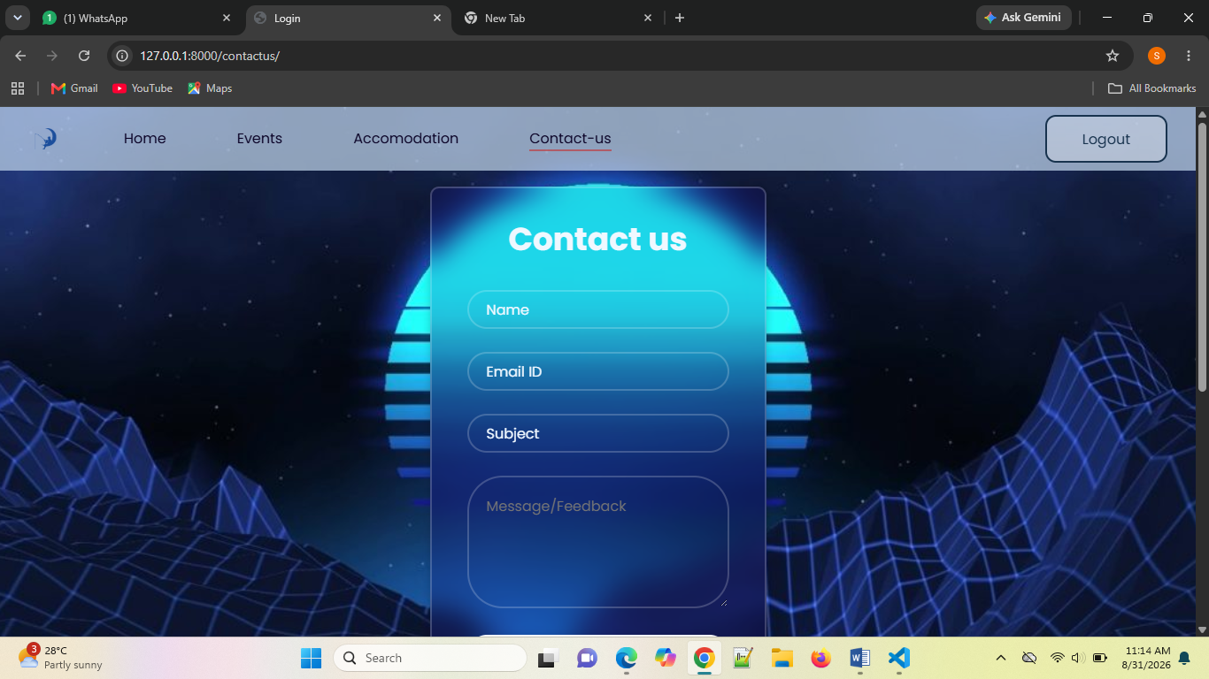

LOGIN:
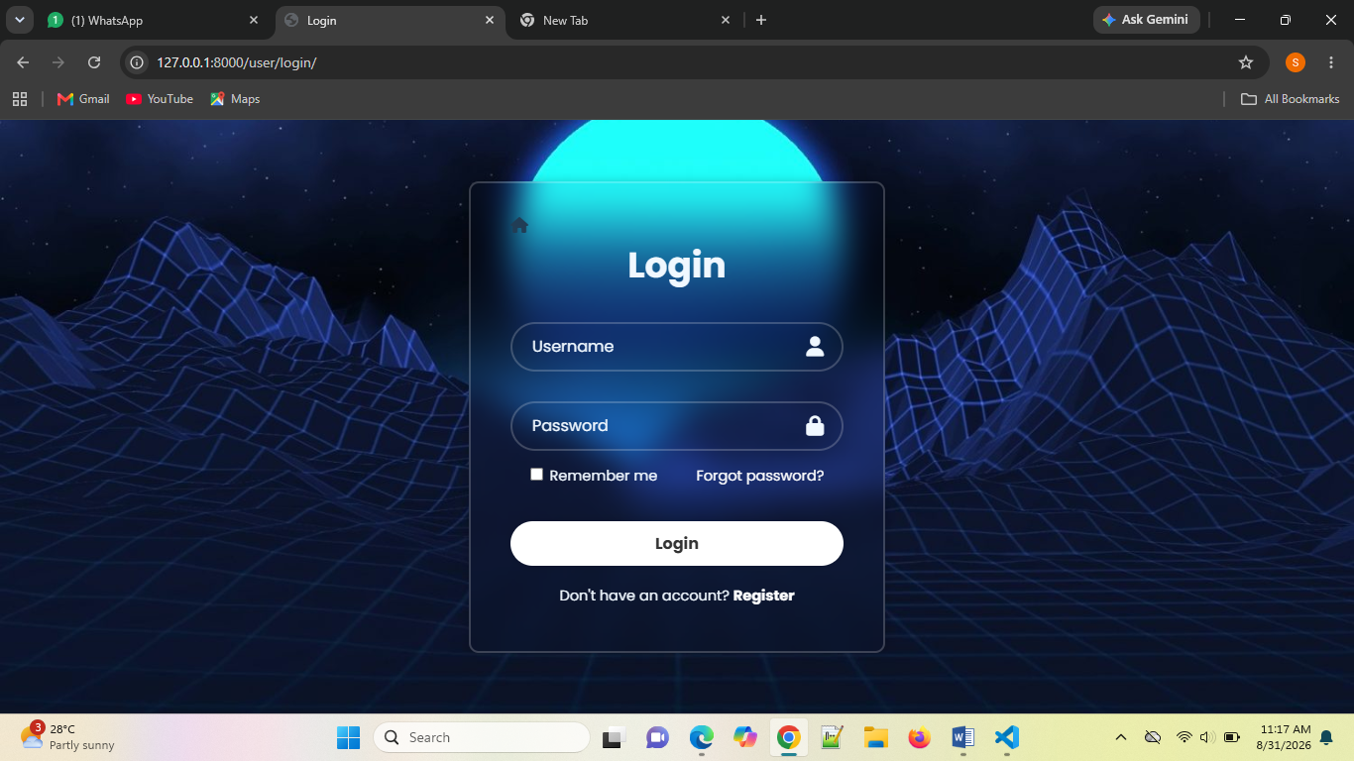
REGISTRATION:
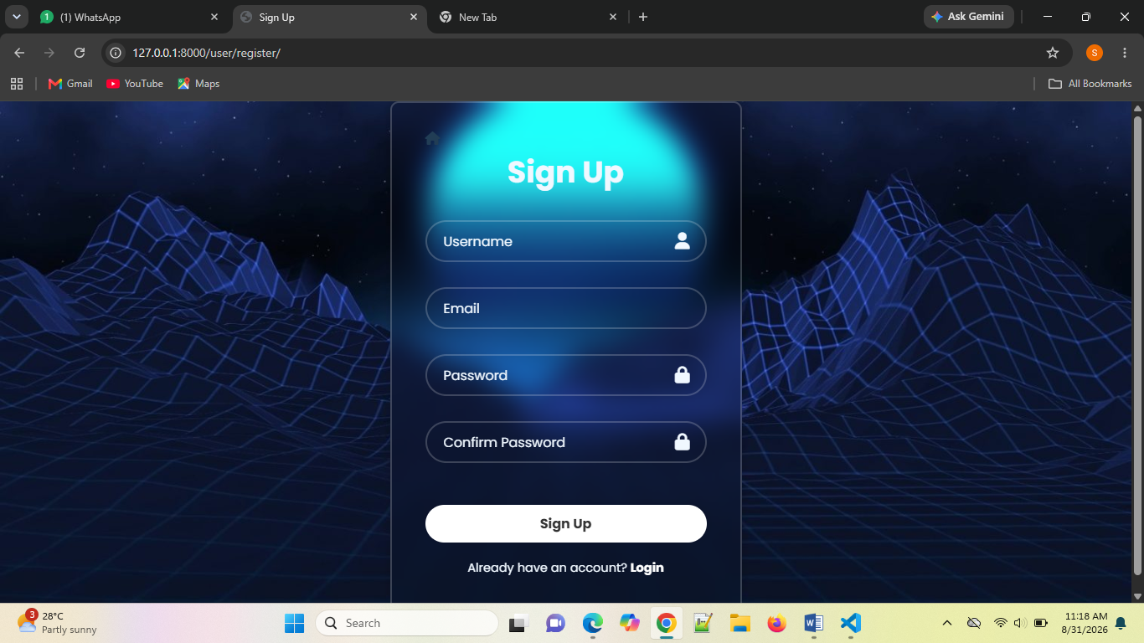
CODING:
Login.html
<!-- login.html -->
{% load static %}
<!DOCTYPE html>
<html lang="en">
<head>
<meta charset="UTF-8">
<meta name="viewport" content="width=device-width, initial-scale=1.0">
<link
rel="stylesheet"
href="https://cdnjs.cloudflare.com/ajax/libs/font-awesome/6.4.2/css/all.min.css"
integrity="sha512-z3gLpd7yknf1YoNbCzqRKc4qyor8gaKU1qmn+CShxbuBusANI9QpRohGBreCFkKxLhei6S9CQXFEbbKuqLg0DA=="
crossorigin="anonymous"
referrerpolicy="no-referrer"
/>
<link rel="stylesheet" href="{% static 'stylelogin.css' %}">
<title>Login </title>

</head>
<body>
<div class="wrraper">
<a href="{% url 'HOME' %}" style ="color:#213d55;"><i class="fa-solid fa-house"></i></a>
<form action="" method="post">
<h1>Login</h1>

<div class="input-box">
<input type="text" name="username" placeholder="Username" >
<i class="fas fa-user"></i>
</div>
{% for error in form.username.errors %}
<span class="error">{{ error }}</span>
{% endfor %}
<div class="input-box">
<input type="password" name="password" placeholder="Password">
<i class="fas fa-lock"></i>
</div>
{% for error in form.password.errors %}
<span class="error">{{ error }}</span>
{% endfor %}
<div class="remember-forgot">
<label >
<input type="checkbox"> Remember me
</label>
<a href="#">Forgot password?</a>
</div>
<button type="submit" class="btn">Login</button>
<div class="register-link">
<p>Don't have an account?
<a href="{% url 'register' %}">Register</a>
</p>
</div>
{% csrf_token %}
</form>
</div>
</body>
</html>

6. Future scope
The Event-Based Management System can be further improved by adding more features and functionality in the future. The system can be enhanced to provide a more complete platform for event management and booking. The possible future enhancements are:
- Online Payment: Integration of an online payment system for event fees and hotel bookings.
- Event Search and Filtering: Adding search and filtering options to help users find events easily.
- Event Categories: Organizing events into different categories for easier navigation.
- Email Notifications: Sending notifications to users for event registrations and hotel bookings.
- Event Reminders: Providing reminders about upcoming events and bookings.
- Improved User Profiles: Adding more profile information and user-specific management features.
- Responsive Design: Improving the interface to provide better usability on mobile phones, tablets, and desktops.
- Event Management Enhancements: Adding additional options for organizers to manage and update their events efficiently.

Conclusion:
The Event-Based Management System provides a structured web-based solution for managing event-related information. The system is developed using Python and Django, with MySQL used for storing and managing the data. It manages important information such as events, users, event registrations, hotels, hotel bookings, user profiles, and contact queries.
The project provides an organized approach to maintaining event and booking records through a centralized system. The use of Django helps in handling application functionality, database operations, and user authentication. Overall, the system successfully provides a simple and efficient platform for managing the different activities and information related to events.
REFERENCES:
· Django Homepage – http://www.djangoproject.com/
· Python Documentation – http://www.python.org/doc
· Django (Web Framework) – http://en.wikipedia.org/wiki/Django
· Django Documentation – http://docs.djangoproject.com
· Python (Programming Language) – http://en.wikipedia.org/wiki/Python
· MySQL Official Site – https://www.mysql.com/
· MySQL Tutorials – http://www.mysqltutorial.org
XAMPP Download & Documentation – https://www.apachefriends.org/download.html

